SUSHILKUMAR YADAV

Q1) Identify the Data type for the Following:
Activity | Data Type
Number of beatings from Wife | Discrete
Results of rolling a dice | Discrete
Weight of a person | Continuous
Weight of Gold | Continuous
Distance between two places | Continuous
Length of a leaf | Continuous
Dog's weight | Continuous
Blue Color | Discrete
Number of kids | Discrete
Number of tickets in Indian railways | Discrete
Number of times married | Discrete
Gender (Male or Female) | Discrete

Q2) Identify the Data types, which were among the following
Nominal, Ordinal, Interval, Ratio.
Data | Data Type
Gender | Nominal
High School Class Ranking | Ordinal
Celsius Temperature | Ratio
Weight | Interval
Hair Color | Nominal
Socioeconomic Status | Nominal
Fahrenheit Temperature | Ratio
Height | Interval
Type of living accommodation | Ordinal
Level of Agreement | Nominal
IQ(Intelligence Scale) | Interval
Sales Figures | Interval
Blood Group | Nominal
Time Of Day | Ordinal
Time on a Clock with Hands | Nominal
Number of Children | Nominal
Religious Preference | Ordinal
Barometer Pressure | Ratio
SAT Scores | Interval
Years of Education | Interval

Q3) Three Coins are tossed, find the probability that two heads and one tail are obtained?
Ans.
S = { HHH , HHT , HTH , THH , TTT , TTH , THT , HTT }
n(S) = 8
P = { HHT , HTH , THH }
n(P) = 3
Probaility of two heads and one tail is = n(P) / n(S)
= 3/8

Q4) Two Dice are rolled, find the probability that sum is
- Equal to 1
- Less than or equal to 4
- Sum is divisible by 2 and 3

Ans.

S = {
(1,1) , (1,2) , (1,3) , (1,4) , (1,5) , (1,6)
(2,1) , (2,2) , (2,3) , (2,4) , (2,5) , (2,6)
(3,1) , (3,2) , (3,3) , (3,4) , (3,5) , (3,6)
(4,1) , (4,2) , (4,3) , (4,4) , (4,5) , (4.6)
(5,1) , (5,2) , (5,3) , (5,4) , (5,5) , (5,6)
(6,1) , (6,2) , (6,3) , (6,4) , (6,5) , (6,6)
}
n(S) = 36

- Sum equal to 1 = { 0}
= 0/36

- Sum less than or equal to 4 = { (1,1) , (1,2) , (1,3) , (2,1) , (2,2) , (3,1) }
=6/36 = 1 / 6

- Sum divisible by 2 and 3 = 29/36.

Q5) A bag contains 2 red, 3 green and 2 blue balls. Two balls are drawn at random. What is the probability that none of the balls drawn is blue?

Ans.
Total number of balls
= (2 + 3 + 2)
= 7
Let S be the sample space
Then, n(S) = Number of ways of drawing 2 balls out of 7
n(S)=7C2
n(S)=(7×6)/(2×1)
n(S)=21
Let E = Event of 2 balls, none of which is blue
Therefore , n(E) = Number of ways of drawing 2 balls out of (2 + 3) balls
n(E)=5C2
n(E)=(5×4)/(2×1)
n(E)=10
∴P(E)=n(E)/n(S)
=10/21

Q6) Calculate the Expected number of candies for a randomly selected child
Below are the probabilities of count of candies for children (ignoring the nature of the child-Generalized view)
CHILD | Candies count | Probability
A | 1 | 0.015
B | 4 | 0.20
C | 3 | 0.65
D | 5 | 0.005
E | 6 | 0.01
F | 2 | 0.120
Child A – probability of having 1 candy = 0.015.
Child B – probability of having 4 candies = 0.20

Ans. Expected number of candies for a randomly selected child
= 1 * 0.015 + 4*0.20 + 3 *0.65 + 5*0.005 + 6 *0.01 + 2 * 0.12
= 0.015 + 0.8 + 1.95 + 0.025 + 0.06 + 0.24
= 3.090
= 3.09
Expected number of candies for a randomly selected child = 3.09

Q7) Calculate Mean, Median, Mode, Variance, Standard Deviation, Range & comment about the values / draw inferences, for the given dataset
- For Points,Score,Weigh>
Find Mean, Median, Mode, Variance, Standard Deviation, and Range and also Comment about the values/ Draw some inferences.
Use Q7.csv file
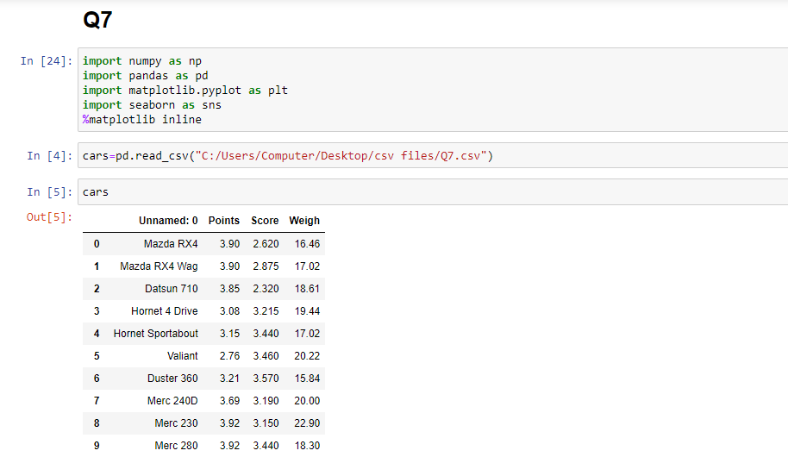
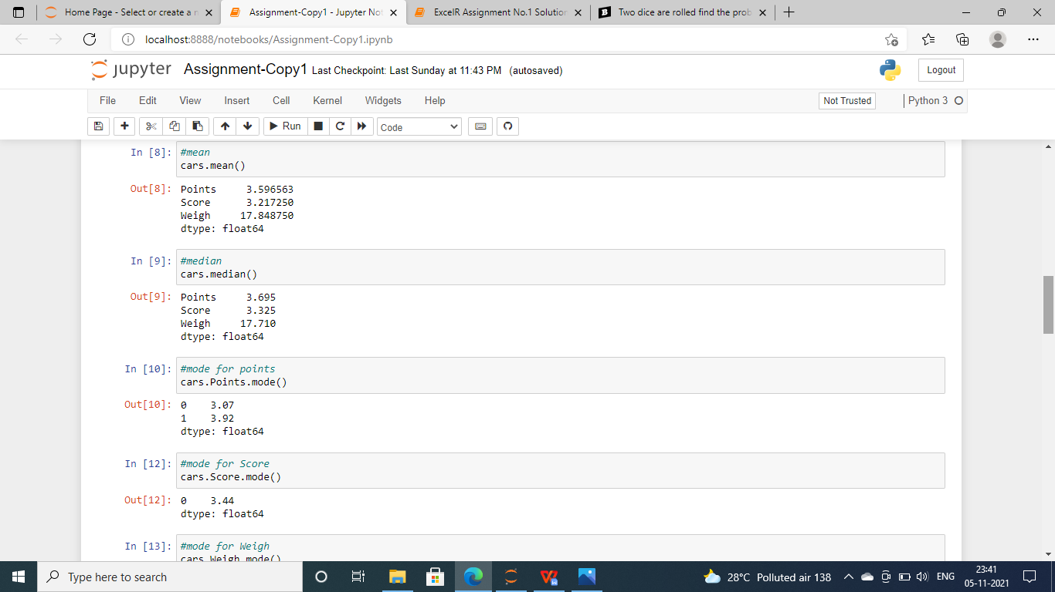
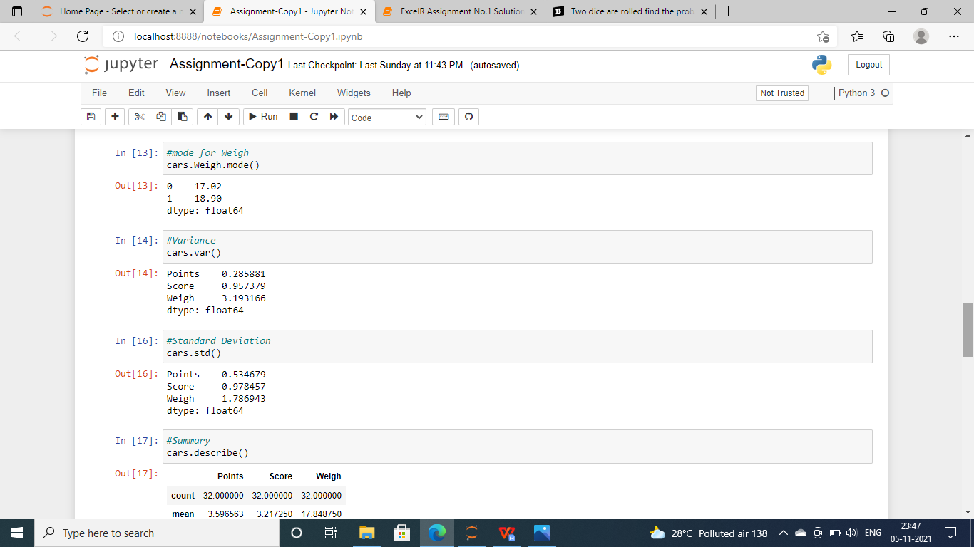
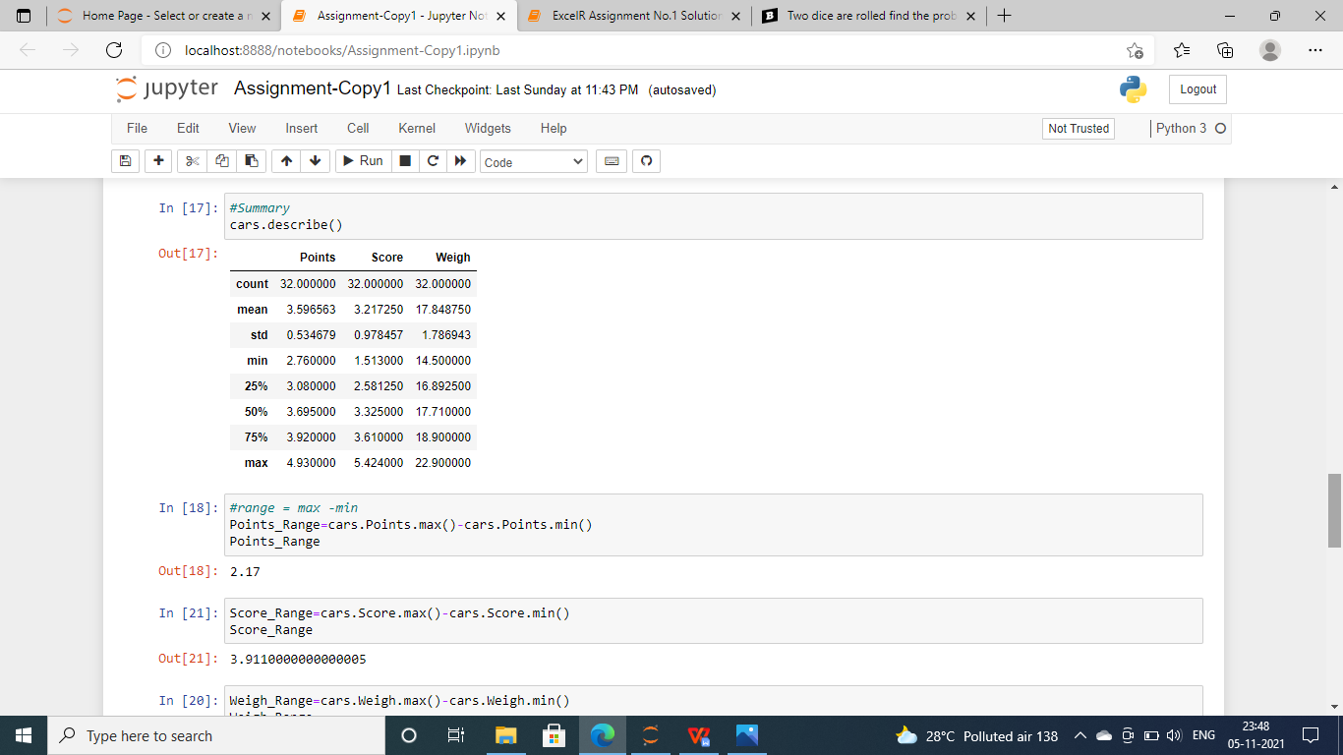
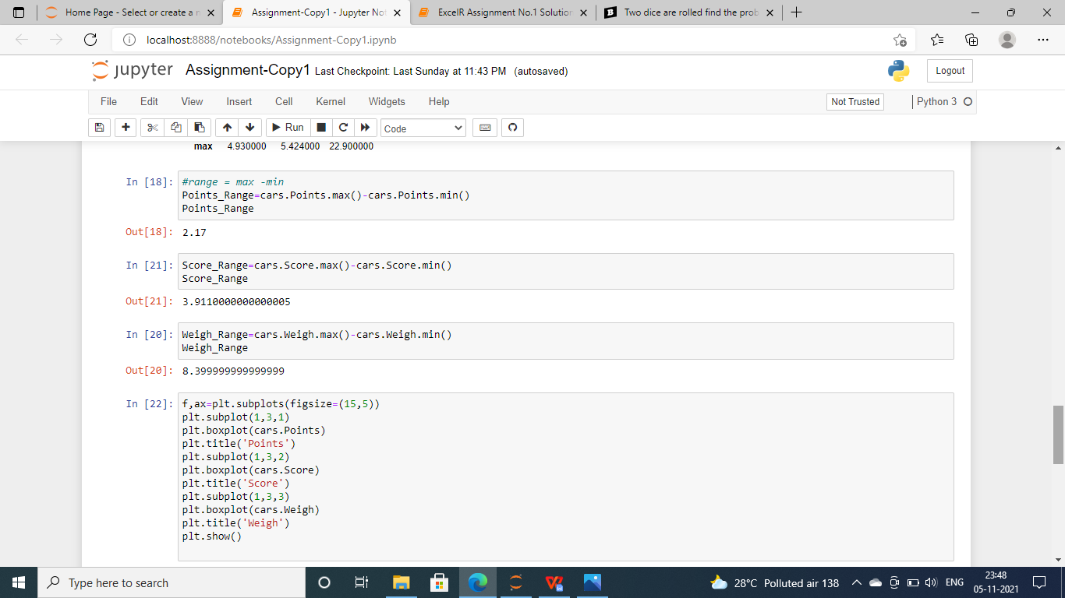

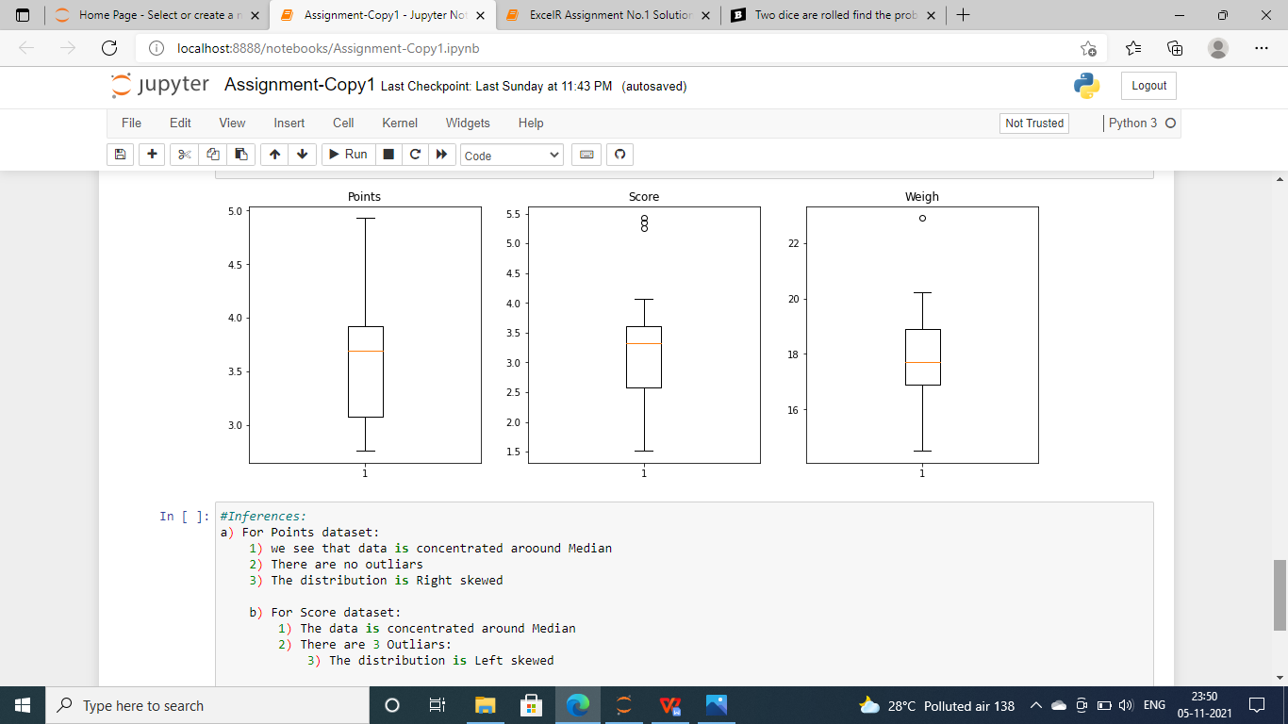
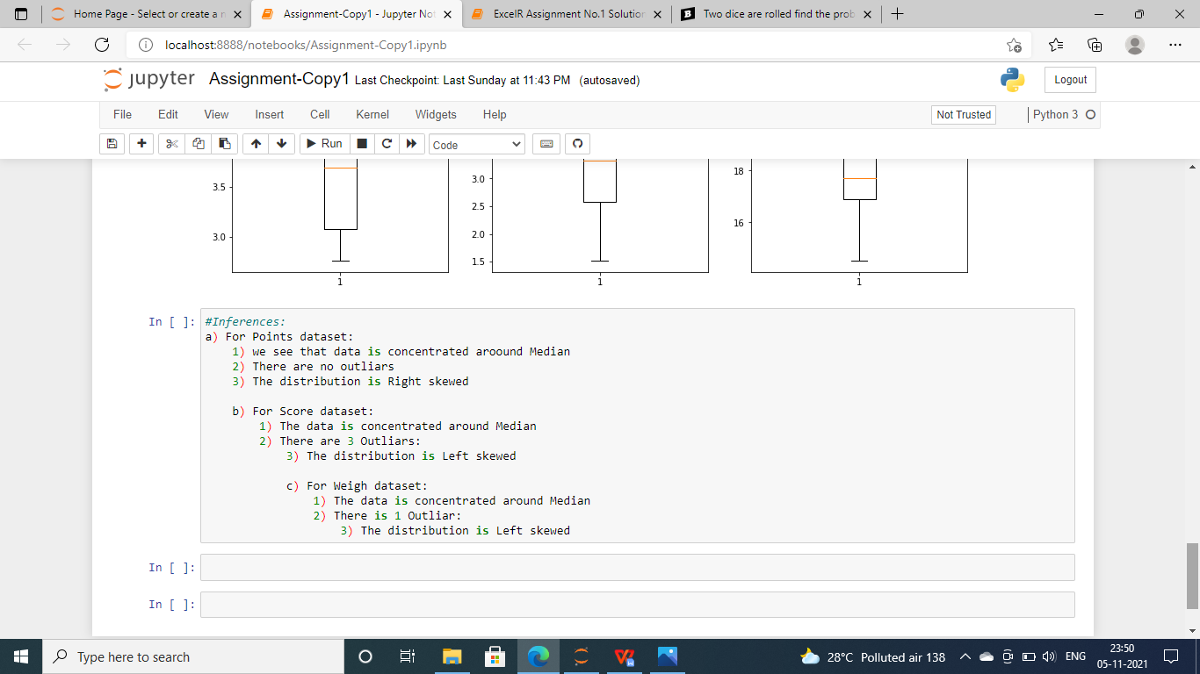
Q8) Calculate Expected Value for the problem below
- The weights (X) of patients at a clinic (in pounds), are
108, 110, 123, 134, 135, 145, 167, 187, 199
Assume one of the patients is chosen at random. What is the Expected Value of the Weight of that patient?
Ans.
We have :
Expected Value = ( probability * Value )
P(x).E(x)
By the given data there are 9 patients ,
So the probability of selecting each patient is 1/9
Ex 108, 110, 123, 134, 135, 145, 167, 187, 199
P(x) 1/9 1/9 1/9 1/9 1/9 1/9 1/9 1/9 1/9
Expected Value = (1/9)(108) + (1/9)110 + (1/9)123 + (1/9)134 + (1/9)135 + (1/9)145+
(1/9(167) + (1/9)187 + (1/9)199
= (1/9) ( 108 + 110 + 123 + 134 + 135 + 145 + 167 + 187 + 199)
= (1/9) ( 1308)
= 145.

Q9) Calculate Skewness, Kurtosis & draw inferences on the following data
Cars speed and distance
Use Q9_a.csv
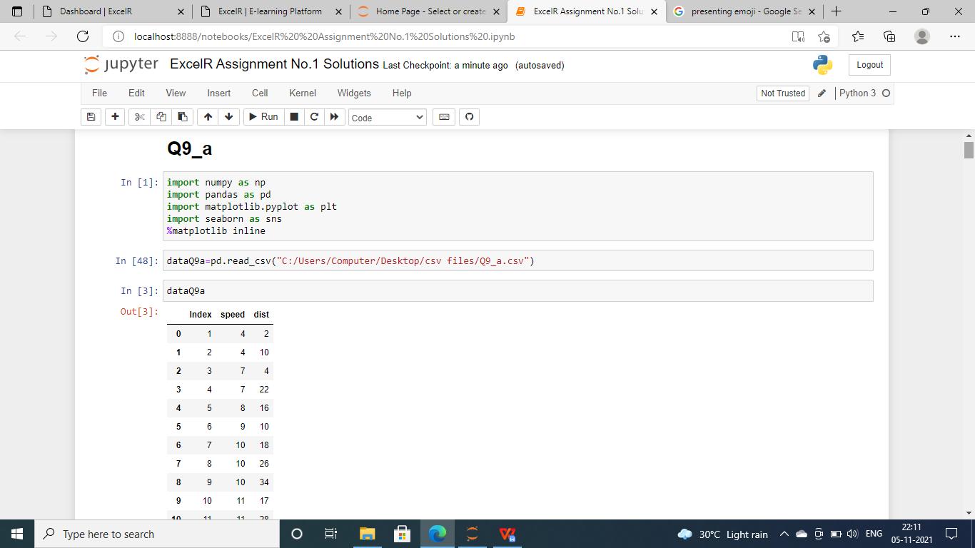
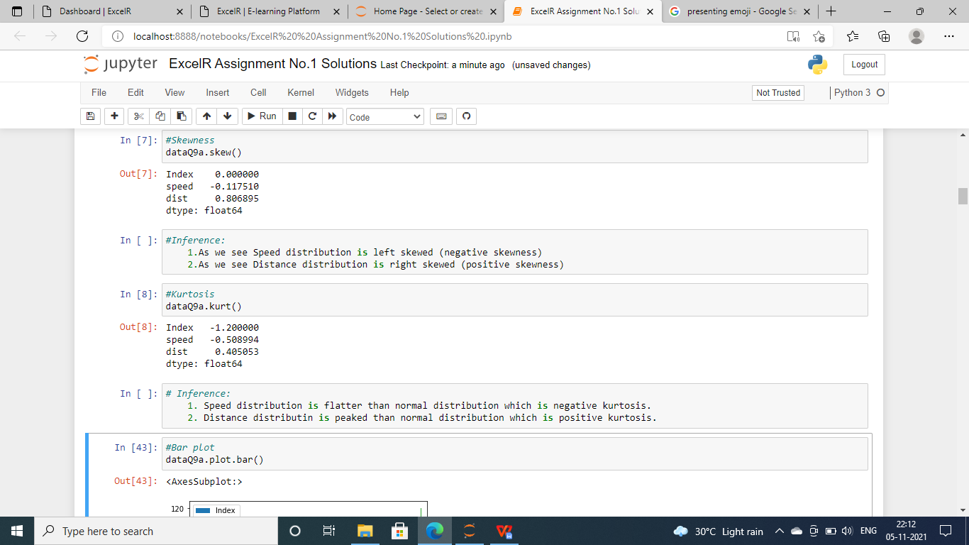

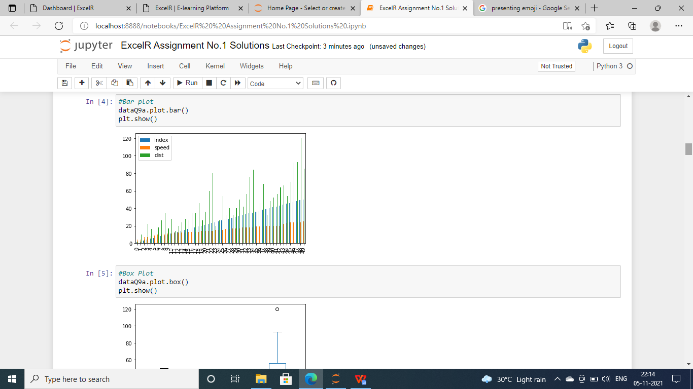
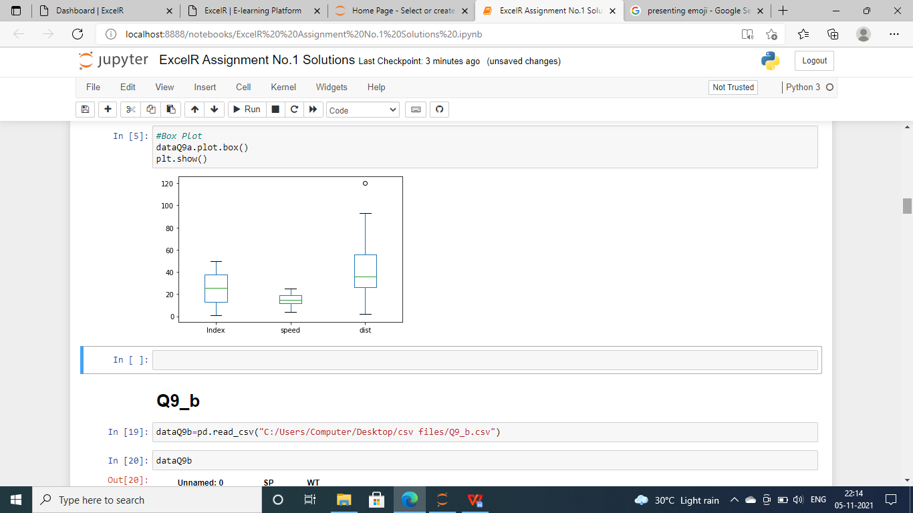

SP and Weight(WT)
Use Q9_b.csv

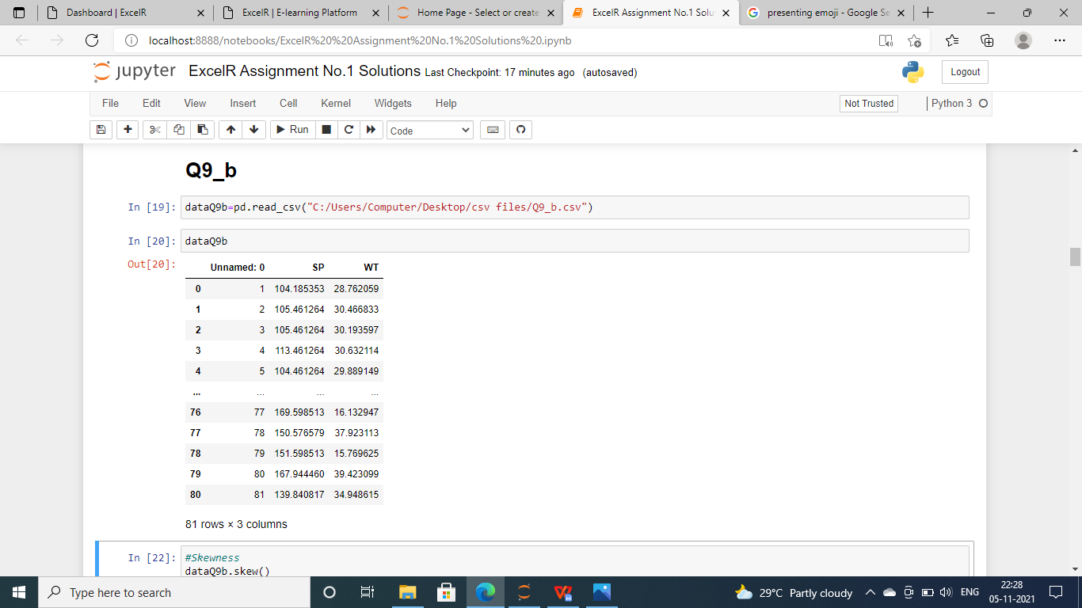
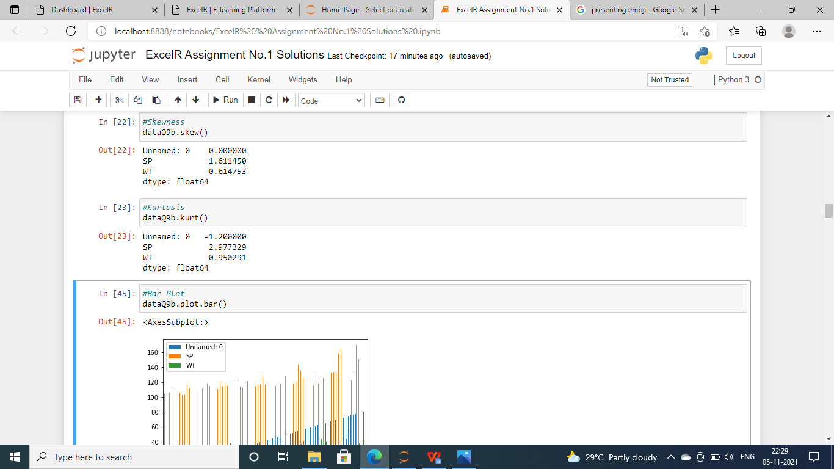
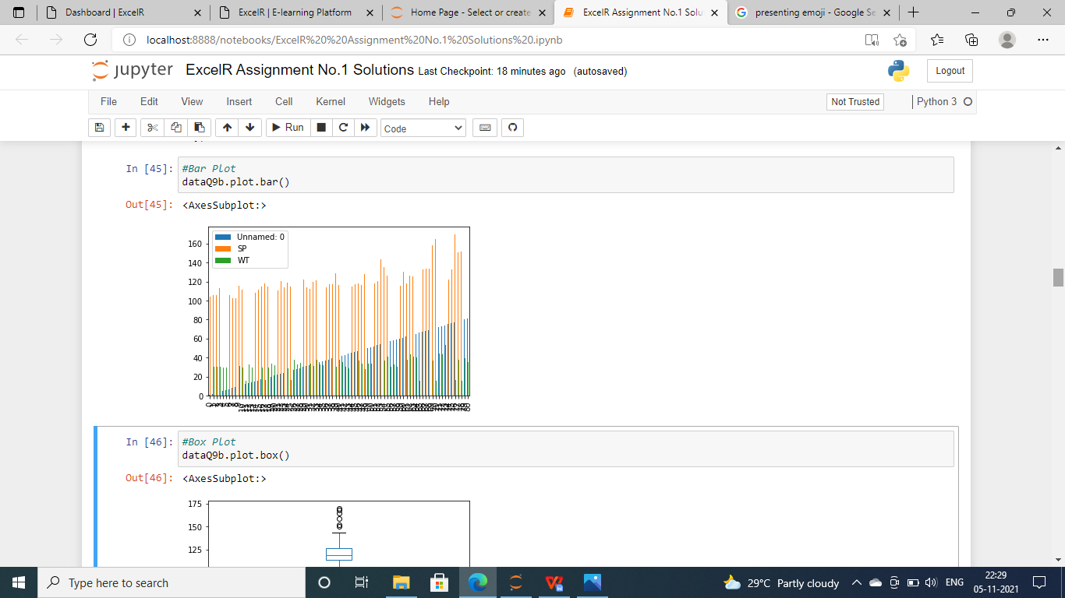

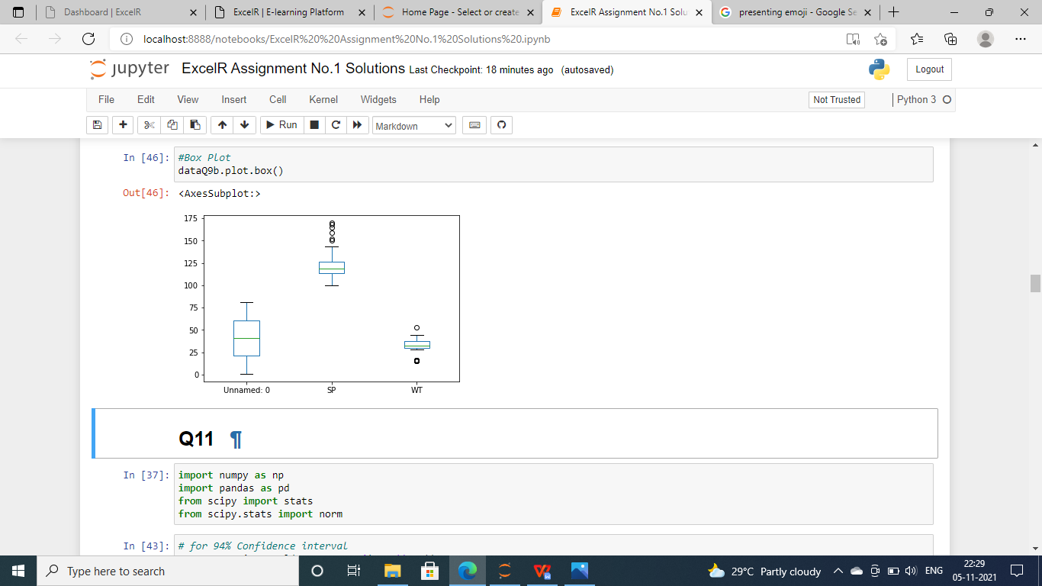

Q10) Draw inferences about the following boxplot & histogram

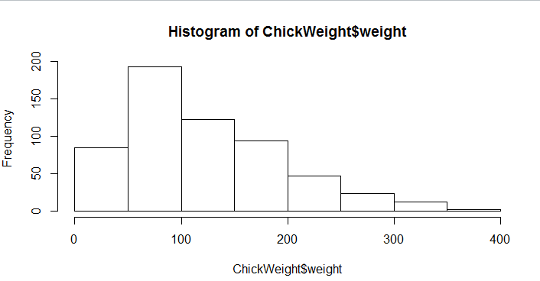

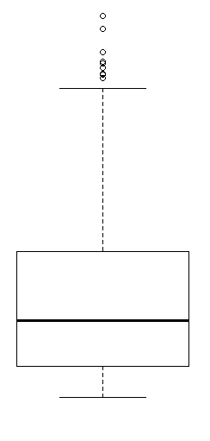

Ans. It shows that the interface of the box is right side skewed or positively skewed.

Q11) Suppose we want to estimate the average weight of an adult male in Mexico. We draw a random sample of 2,000 men from a population of 3,000,000 men and weigh them. We find that the average person in our sample weighs 200 pounds, and the standard deviation of the sample is 30 pounds. Calculate 94%,98%,96% confidence interval?
Ans.
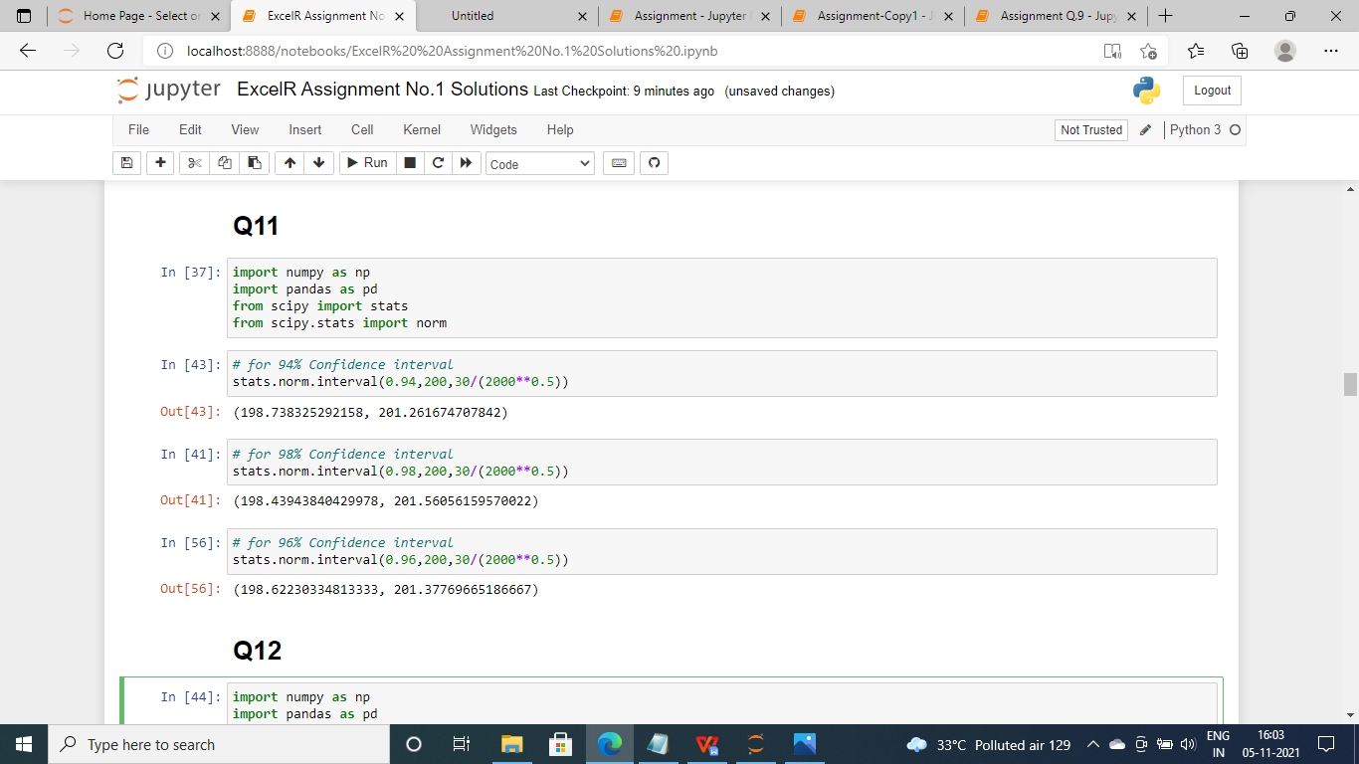

Q12) Below are the scores obtained by a student in tests
34,36,36,38,38,39,39,40,40,41,41,41,41,42,42,45,49,56
- Find mean, median, variance, standard deviation.
- What can we say about the student marks?

Ans.
The marks of the students are in uniformly distribution data in ascending order.
So the mean , median , variance and standard deviation will be :
Mean = 41
Median = 40.5
Variance = 25.52
Standard Deviation = 5.05

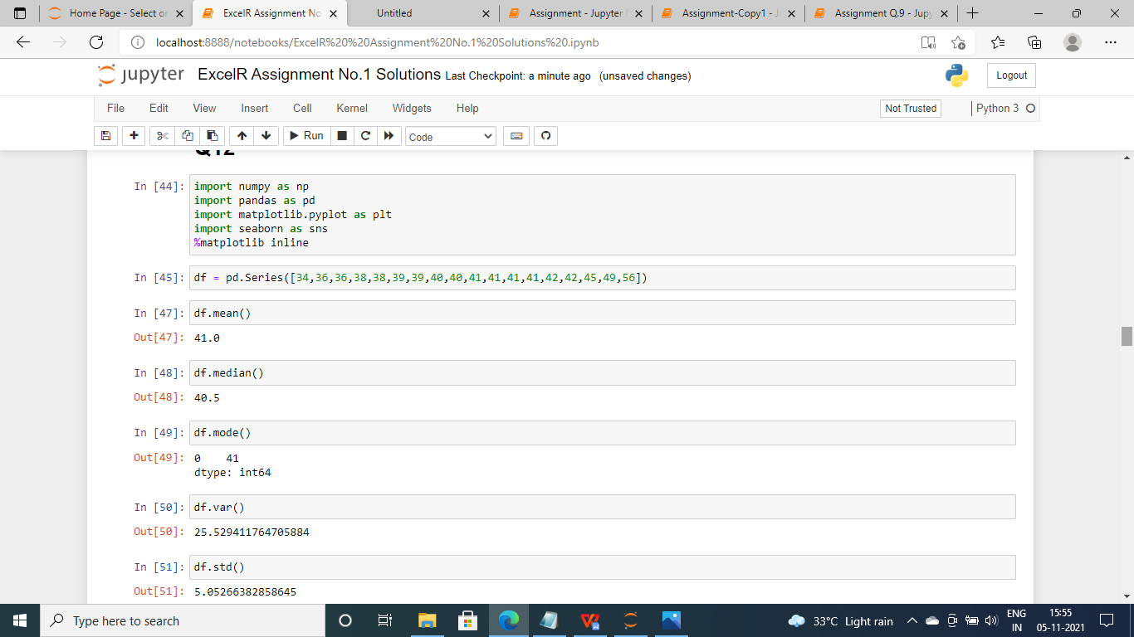

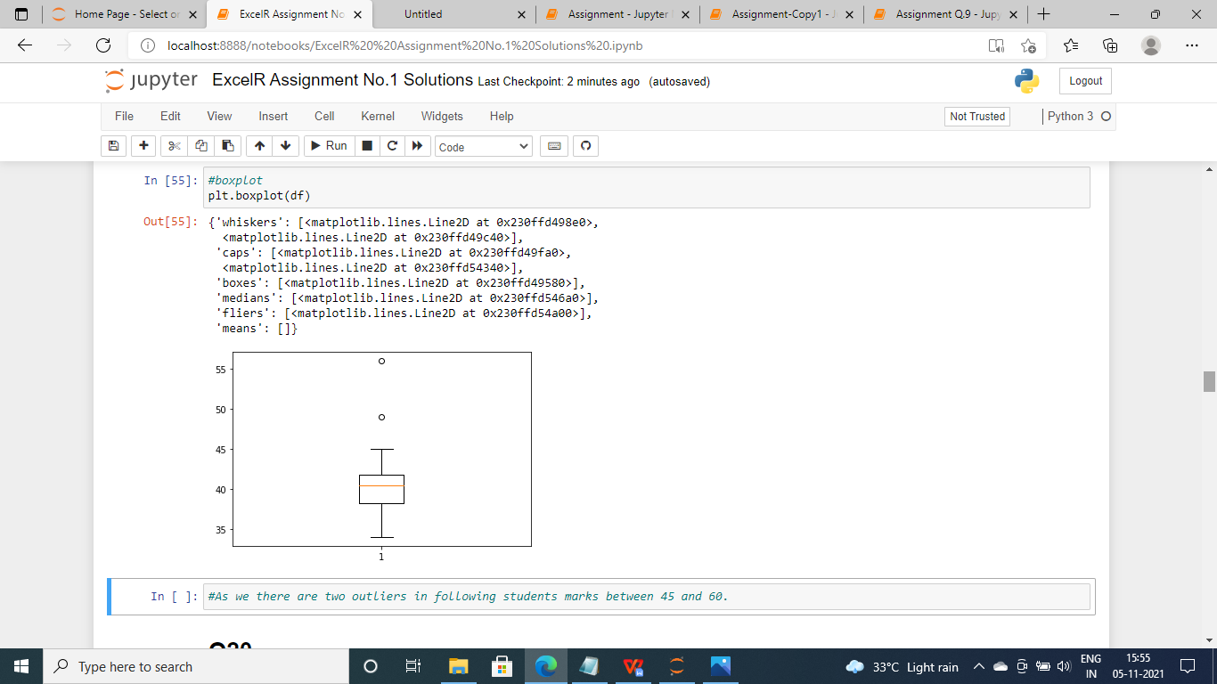

Q13) What is the nature of skewness when mean, median of data are equal?
Ans. It shows the nature is Normalized Skewness

Q14) What is the nature of skewness when mean > median ?
Ans. It shows the nature is Right Skewed

Q15) What is the nature of skewness when median > mean?
Ans. It shows the nature is left skewed.

Q16) What does positive kurtosis value indicates for a data ?
Ans. It indicates the peak is narrow in the plot and has less gap between tails towards x-axis.

Q17) What does negative kurtosis value indicates for a data?
Ans. It indicates border peak under the curve and and there is more gap between tails and x-axis.

Q18) Answer the below questions using the below boxplot visualization.
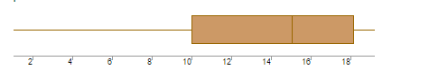
What can we say about the distribution of the data?
Ans. The data is distributed in skewed format.

What is nature of skewness of the data?
Ans. The nature of the skewness of data is Left side skewed

What will be the IQR of the data (approximately)?
Ans. Q3-Q1 = 18-10
= 8 is IQR

Q19) Comment on the below Boxplot visualizations?
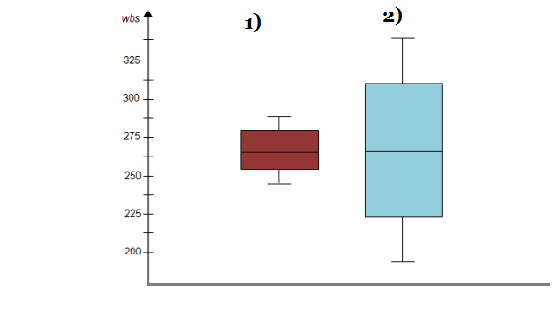
Draw an Inference from the distribution of data for Boxplot 1 with respect Boxplot 2.
Ans. The box plot 1 designed with range = 3
The second one range is = 1.5

Q 20) Calculate probability from the given dataset for the below cases

Data _set: Cars.csv
Calculate the probability of MPG of Cars for the below cases.
MPG <- Cars$MPG
  - P(MPG>38)
  - P(MPG<40)
c. P (20<MPG<50)
Ans :
- P(MPG>38)-
1-pnorm(38,34.422,9.13144) = 0.3475908

. B. P(MPG<40)-
pnorm(40,34.422,9.13144) = 0.7293527

C.. P (20<MPG<50)-
pnorm(50,34.422,9.13144)-(1-pnorm(20,34.422,9.13144)) = 0.01311818

Q 21) Check whether the data follows normal distribution
- Check whether the MPG of Cars follows Normal Distribution
Dataset: Cars.csv
Ans :
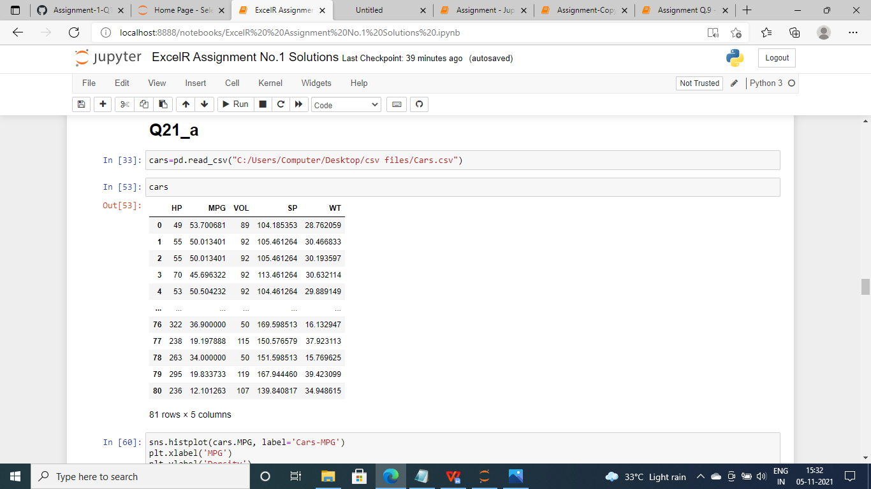

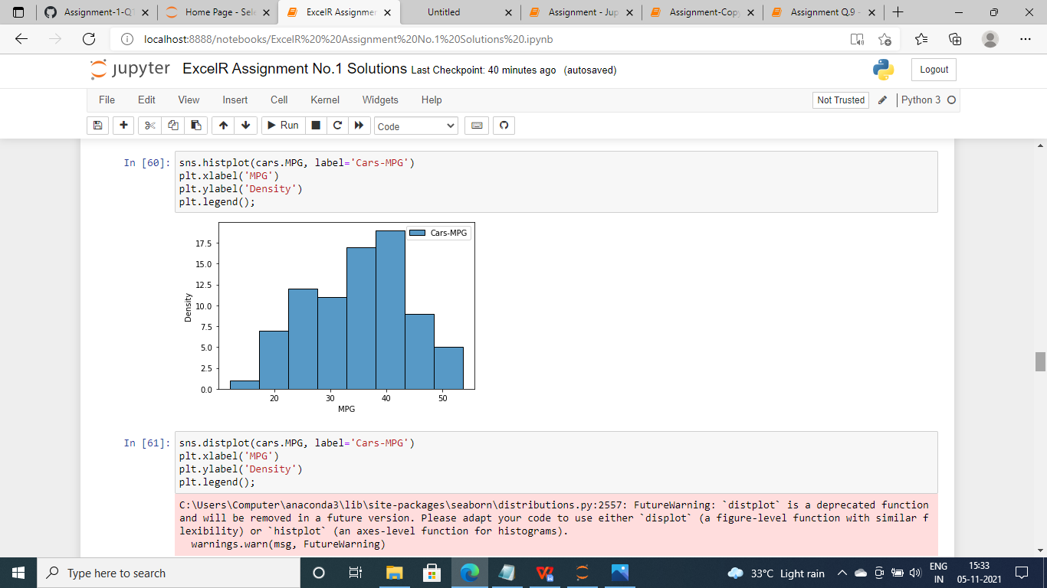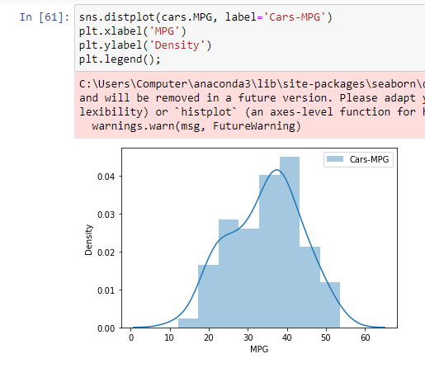

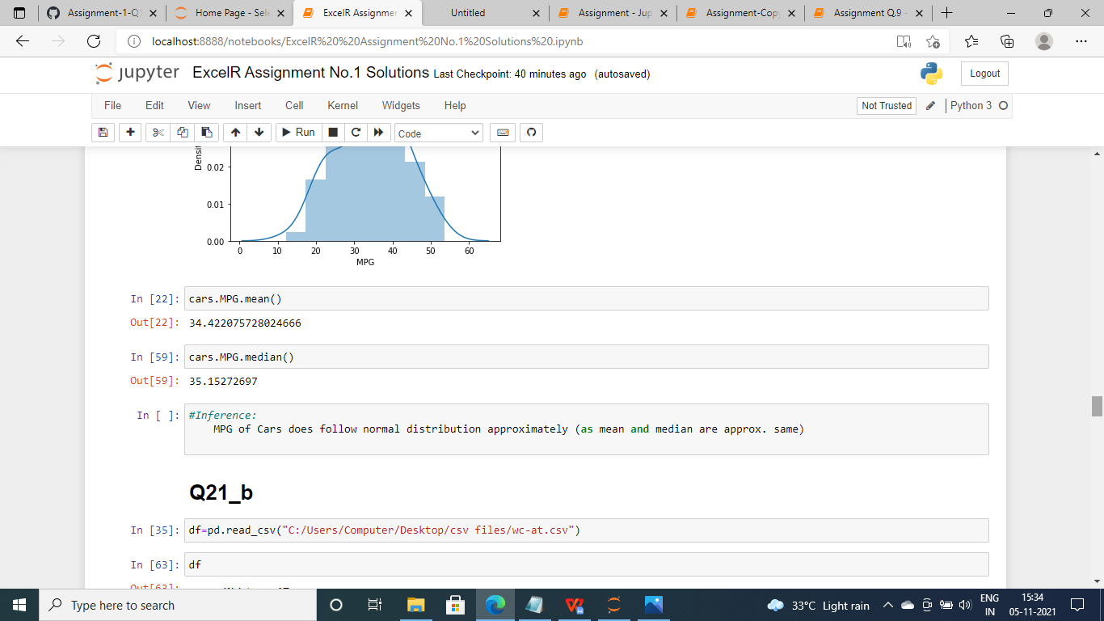

- Check Whether the Adipose Tissue (AT) and Waist Circumference(Waist) from wc-at data set follows Normal Distribution
Dataset: wc-at.csv

Ans :

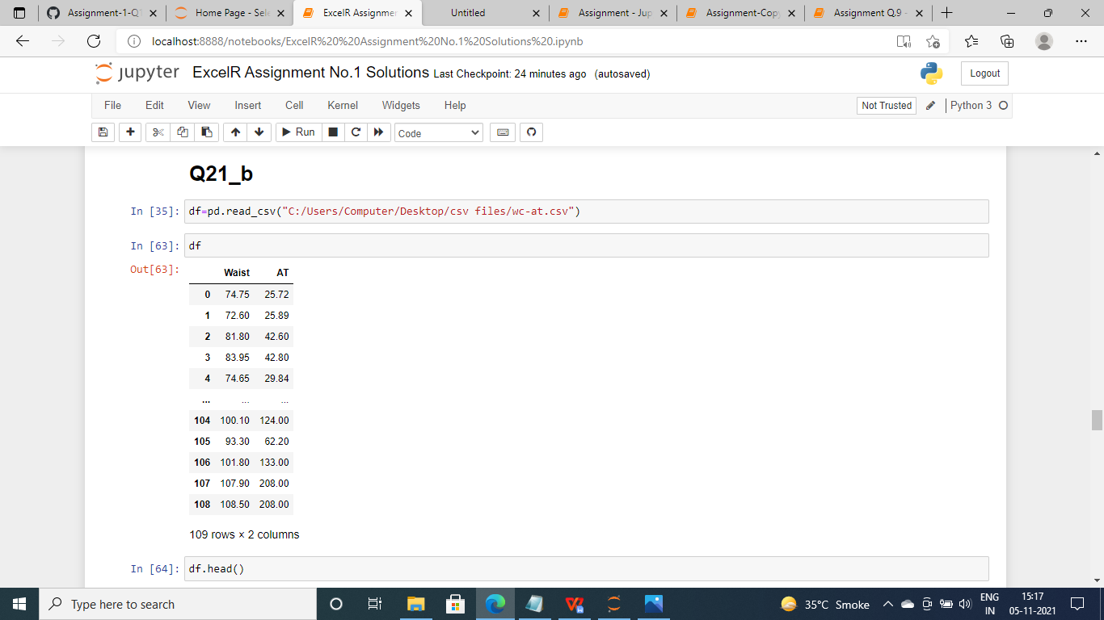

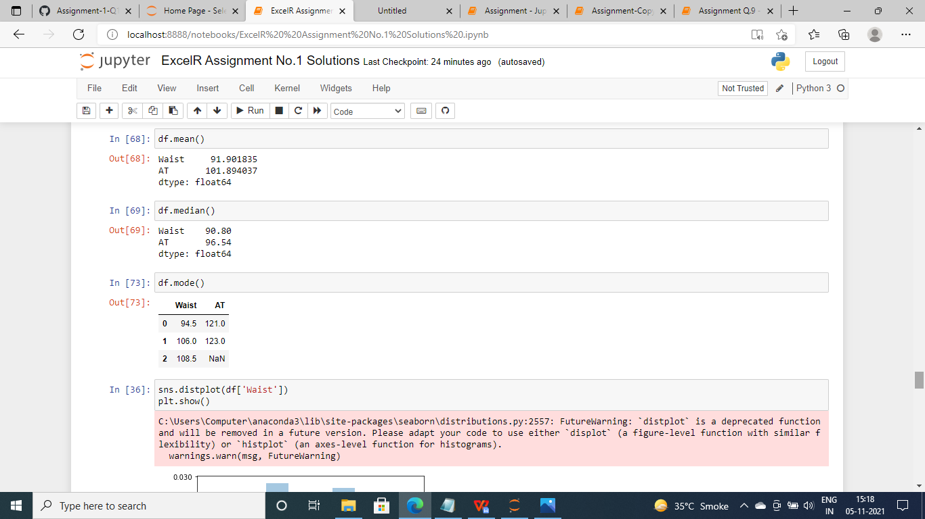

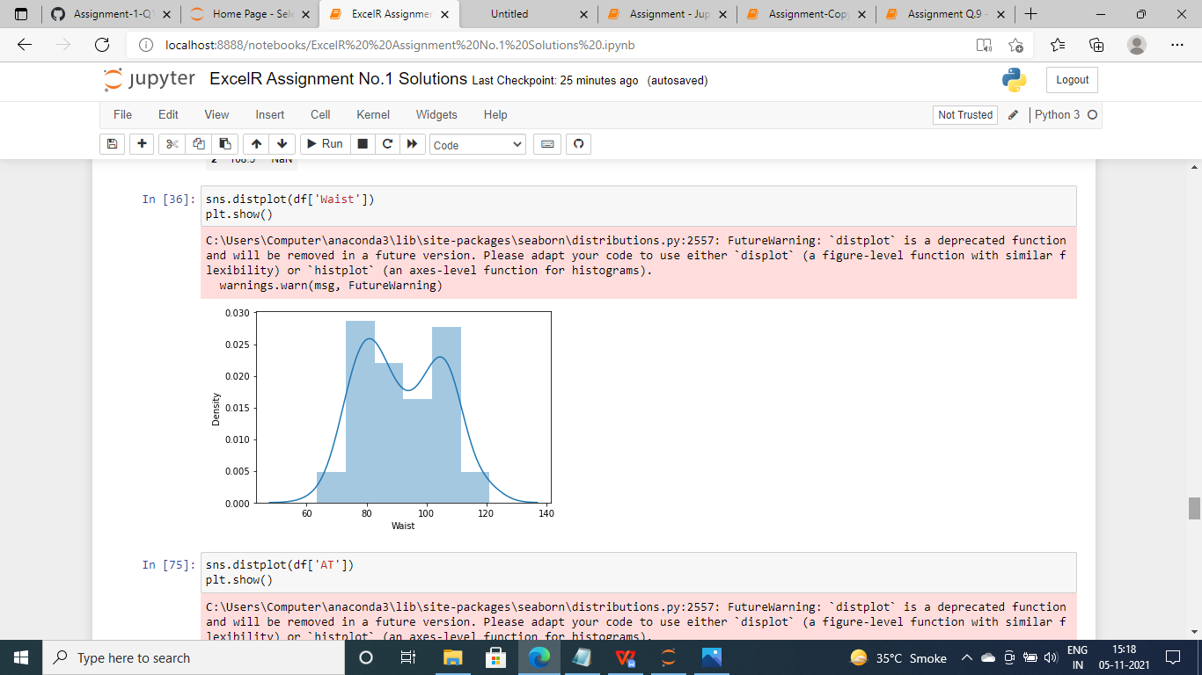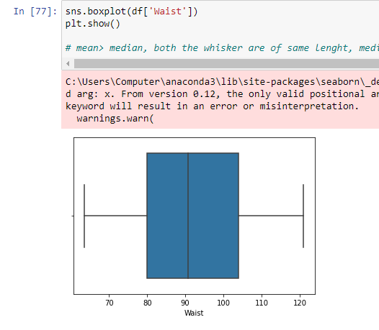

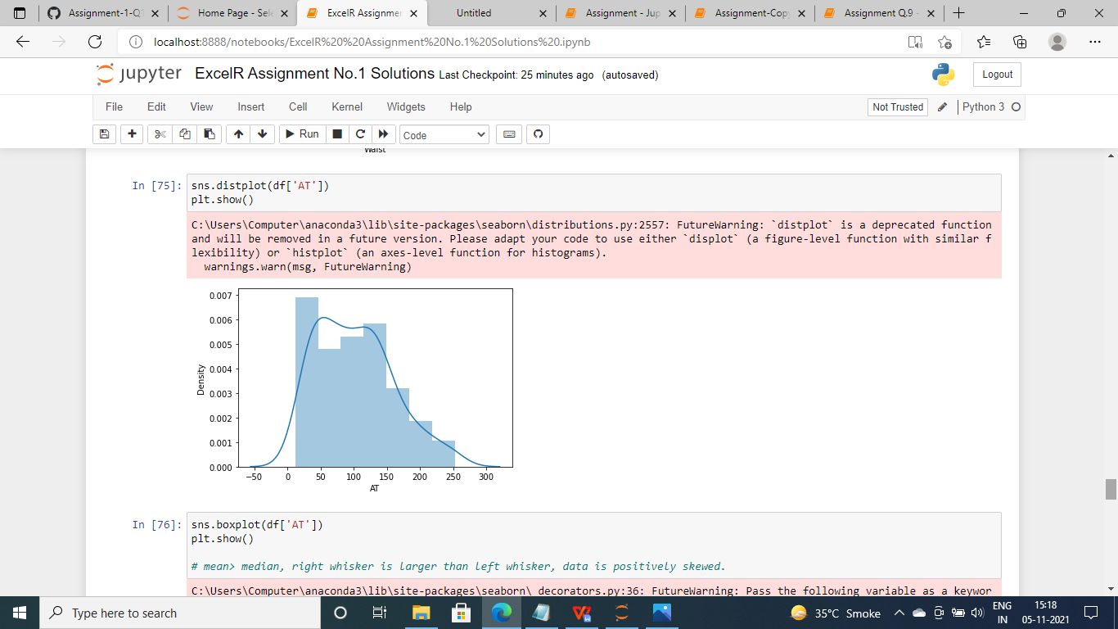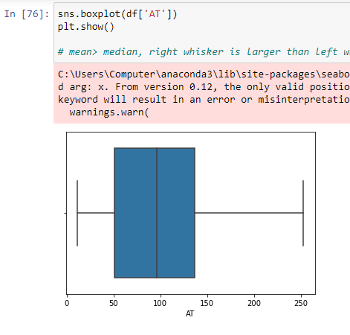

Q 22) Calculate the Z scores of 90% confidence interval,94% confidence interval, 60% confidence interval

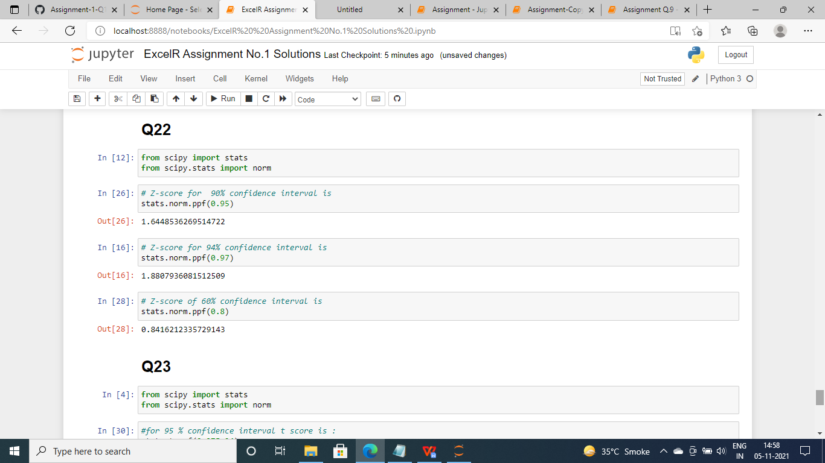
Confidence Interval | Z-score
60% | 0.8416212
90% | 1.644854
94% | 1.880794

Q 23) Calculate the t scores of 95% confidence interval, 96% confidence interval, 99% confidence interval for sample size of 25
Ans :

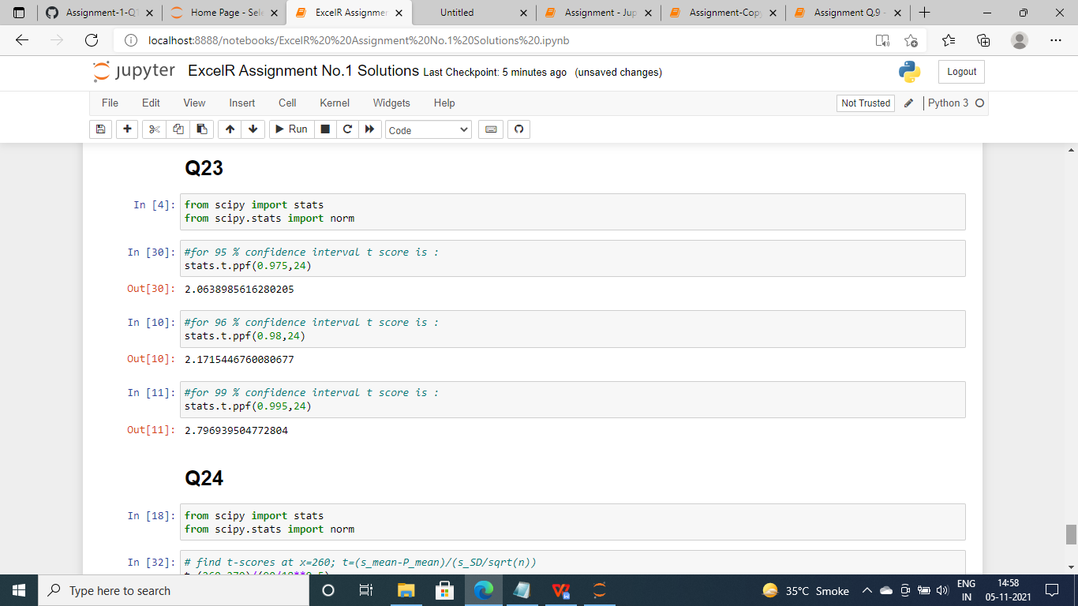

Confidence Interval | T-score
95% | 2.063899
96% | 2.171545
99% | 2.79694

Q 24) A Government company claims that an average light bulb lasts 270 days. A researcher randomly selects 18 bulbs for testing. The sampled bulbs last an average of 260 days, with a standard deviation of 90 days. If the CEO's claim were true, what is the probability that 18 randomly selected bulbs would have an average life of no more than 260 days
Hint:
rcode pt(tscore,df)
df degrees of freedom

Ans.
We have the foolowing data :
x = mean of the sample of bulbs = 260
μ = population mean = 270
s = standard deviation of the sample = 90
n = number of items in the sample = 18
t = [ 260-270 | 90/sqrt of 18 ]
We get , t = - 0.471
We have formula for , degrees of freedom is n - 1, so we will get 18-1 =17
We want , t-distribution with 17 degrees of freedom.
So the probability of t < - 0.471 with 17 degrees of freedom assuming the population mean is true, the t-value is less than the t-value obtained With 17 degrees of freedom and a t score of - 0.471.
So the probability of the bulbs lasting less than 260 days on average of 0.3218 assuming the mean life of the bulbs is 300 days.
